Software Requirement Specifications

Blood Donation Management System


Submitted by

Nimra Afzal

Roll No

F22NINFT1M01040

Submitted to

Mr.Faisal Shahzad

Department of Information Technology
Faculty of Computing
The Islamia University of Bahawalpur

1. Introduction

Purpose
The purpose of this SRS is to define all requirements for the Blood Donation Management System. The system will help manage blood donors, recipients, blood stock, donation requests, and hospital coordination. It ensures quick availability of required blood groups and improves the donation process.

Scope
The system will:
- Register blood donors
- Store donor medical details
- Handle blood donation requests
- Manage blood bank inventory
- Connect donors, hospitals, and recipients
- Generate notifications and reports
- The system supports hospitals, blood banks, and volunteer donors.

Definitions
Donor: A person who donates blood.
Recipient: A person who needs blood.
Blood Bank Admin: Manages blood stock and system operations.

2. Overall Description

Product Perspective
This is a web-based application that centralizes donor records, donation requests, and available blood stock.

Product Features
- Donor registration
- Blood group verification
- Blood stock management
- Donation request handling
- Search system for required blood groups
- Hospital management module
- Notifications & reminders
- Report generation

User Classes
Donor: Registers and donates blood
Admin: Manages blood stock and donor records
Hospital: Requests and receives blood units

Operating Environment
- Works on Windows, Android, iOS
- Accessible on Chrome, Firefox, Safari
- Requires internet connection

3. System Features (Functional Requirements)

Donor Registration
- User can register with name, age, blood group, contact, medical history
- System validates medical eligibility

Login System
- Donor, Admin, and Hospital login
- Password verification and reset

Donor Dashboard
- View donation history
- Next eligible donation date
- Update profile

Blood Stock Management (Admin)
- Add or update blood units
- Mark units as expired or used
- total stock for each blood group

Blood Request System
- Hospital can request required blood group and quantity
- Admin approves or rejects requests
- System notifies when blood is available

Donor Search
- System searches registered donors by blood group, location
- Sends notifications to nearby eligible donors

Notifications
- Donors get reminders for next donation
- Hospitals receive request updates
- Admin gets low-stock alerts

Reports
- Daily/weekly blood usage
- Donor lists
- Stock status

4. Non-Functional Requirements

Performance
- System responds within 2–3 seconds
- Supports multiple simultaneous users

Security
- Password encryption
- Only authorized users access sensitive data
- Data backup daily

Usability
- Clean and simple interface
- Easy navigation for donors and hospitals

Reliability
- System available 24/7
- No data loss during operations

Scalability
- Can support multiple cities, hospitals, and thousands of donors

5. Constraints
- Internet required
- Accuracy depends on donor information
- Medical tests must be done physically

6. Assumptions
- Donors provide correct personal and medical details
- Hospitals use system responsibly
- Admin updates stock regularly

7. UML Diagrams (Optional)
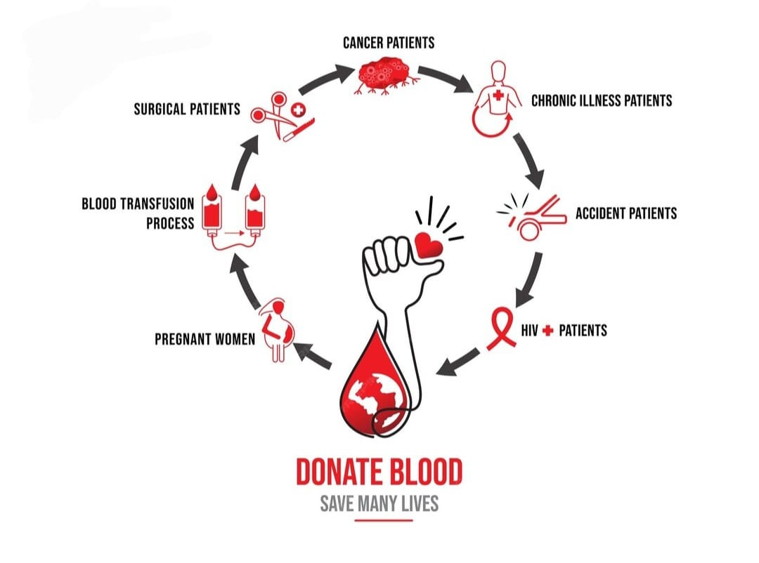

8. Conclusion

This SRS provides detailed functional and non-functional requirements for the Blood Donation Management System. It centralizes blood donation operations and ensures timely availability of blood to those in need.

